Matthew Tran
Configuring GRUB Security
I secured the GRUB bootloader on Ubuntu by hiding its menu, creating a privileged superuser and a restricted regular user, then verified and applied the changes through a reboot. This hardened the system against unauthorized startup access.
Tools I used…
- Ubuntu Virtual Machine
- GRUB Bootloader
- gedit
Some skills I learned are …
- Configuring GRUB settings to improve system security
- Hiding the GRUB menu to prevent unauthorized boot access
- Creating a GRUB superuser with full administrative privileges
- Creating a regular user with limited access
- Using Linux commands to manage users and permissions
- Verifying security changes through system files and reboot testing
export PS1='matthew_tran@vm:\w$ '
Personalizes the terminal
Task 1) Hiding the GRUB Menu and Setting Automatic Boot
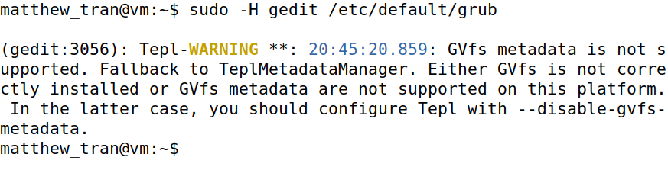
sudo -H gedit /etc/default/grub
This opens the GRUB configuration for editing. This file controls GRUB's behavior during boot; changes here will secure the system.
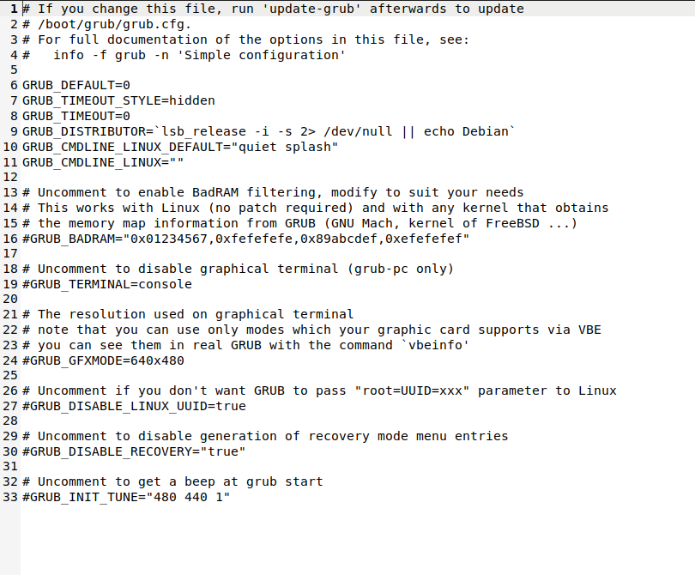
GRUB_DEFAULT=0
This line makes sure that the boot option is default to the first operating system within the GRUB menu. It makes sure that the default operating system is automatically chosen when the system boots up, which will lead to system stability and security.
GRUB_TIMEOUT_STYLE=hidden
This will hide the GRUB menu when the boot starts. This will reduce the risk of any unauthorized users messing with the boot process.
GRUB_TIMEOUT=0
This sets the timeout to 0 seconds, which means that the system will boot without displaying anything. This is important and useful because not only will it be safer from people who might want to tamper with the boot menu, but it also saves a lot of time considering that the boot menu will most likely not be used every time you need to start your system.
Task 2) Creating a Superuser Account for GRUB
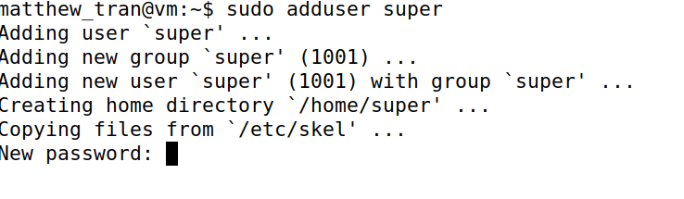sudo adduser super
This step adds a new user named “super.” The user will be given many abilities to configure with the bootloader settings.
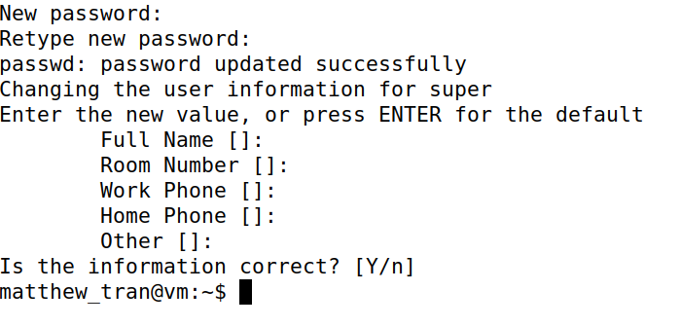
PWD = noaccess
This assigns a simple password. Although simple, it is another layer of protection.
sudo usermod –aG sudo super
This command will add the user “super” to the sudo group, greatening the privileges the user already had and more. This is vital to keep control over the GRUB menu and system security in general.
Task 3) Creating a Regular User Account for GRUB
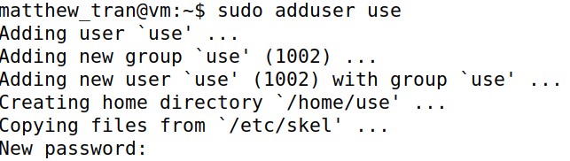
sudo adduser user
This command adds the user called “user.” The user will have less privileges compared to the “super” user, but it shows the difference in levels of access and power in the GRUB bootloader.
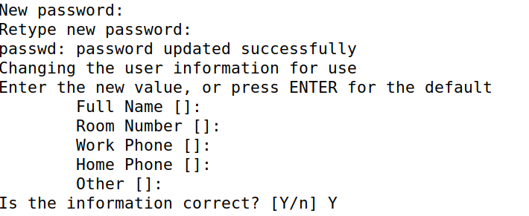
PWD = secured
Once more this command just sets a password/ another layer of defense.
4) Verification and System Reboot
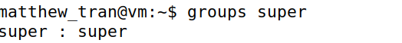
groups super
This command will then check which group the user “super” belongs to. It will confirm whether or not the user is actually in the sudo group for administrative privileges or not.

sudo reboot
This reboots the system, allowing the changes made in the GRUB system to take place. GRUB system will only take effect after the system is rebooted.
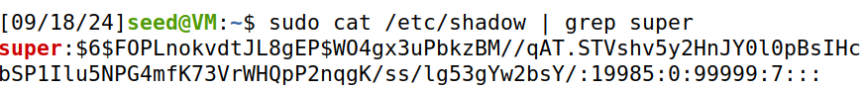sudo cat /etc/shadow | grep super
This command will check the /etc/shadow file for the user “super.” It will ensure the user was created. The password also starts with $6$ which indicates the SHA-512 hashing algorithm, ensuring safety.
sudo cat /etc/shadow | grep user
This has the same purpose, only this command was specified for the other user made, “user.”

